**A**

**Project Report**

**On**

**"B-CHAT"**

**Prepared by**

Yash Shiyani (18DCE125)

Manan Patel (D19DCE156)

Sakshi Davada (D19DCE170)

**Under the guidance of**

Asst. Prof. Krishna Patel

A Report Submitted to

Charotar University of Science and Technology

For Partial Fulfillment of the Requirements for the

5th Semester Summer Internship-I (CE346)

**Submitted at**



**Department of Computer Engineering**

**Devang Patel Institute of Advance Technology and Research**

**At: Changa, Dist: Anand – 388421**

**June 2020**



**CERTIFICATE**

This is to certify that the report entitled “**CHATAPP**” is a bonafide work carried out by **Mr. Yash Shiyani(18DCE125), Mr. Manan Patel(D19DCE156), Ms. Sakshi Davada(D19DCE170)** under the guidance and supervision of **Asst. Prof. Krishna Patel** for the subject **CE346 Summer Internship-I** of 5th Semester of Bachelor of Technology in **Department of Computer Engineering,** **DEPSTAR** at Faculty of Technology & Engineering – CHARUSAT, Gujarat.

To the best of my knowledge and belief, this work embodies the work of candidate himself, has duly been completed, and fulfills the requirement of the ordinance relating to the B.Tech. Degree of the University and is up to the standard in respect of content, presentation and language for being referred to the examiner.

|  |  |
| --- | --- |
| Asst.Prof. Krishna Patel  Assistant Professor Cum research Fellow  Department of Computer Science & Engineering  DEPSTAR, CHARUSAT, Changa, Gujarat. |  |
| Prof. Dweepna Garg  I/C Head of Department  Department of Computer Engineering  DEPSTAR, CHARUSAT, Changa, Gujarat | Dr. Amit Ganatra  Principal, DEPSTAR  Dean, FTE  CHARUSAT, Changa, Gujarat. |

**Devang Patel Institute of Advance Technology And Research,**

**Charotar University Of Science And Technology**

**At: Changa, Ta. Petlad, Dist. Anand, PIN: 388 421. Gujarat**

**ACKNOWLEDGEMENT**

"Words have never expressed human sentiments. This is only an attempt to express my deep gratitude which comes from my heart.

It is great pleasure for me to express my deep feeling of gratitude to my respected guide **Asst. Prof. Krishna Patel** (Assistant Professor) for their great encouragement and constant support which provided desired moral and confidence to carry on my work. It is with profound gratitude that I wish to express my gratefulness to them for their valuable and expert guidance and Supervision in completion of this project work.

I would also like to thank **Dr. Amit Ganatra Sir** (Principal) for allowing us to work on this project.

I am grateful to my parents for their lovable support. Last but not least I am thankful to my friends & other faculty members for their direct & indirect help for completion of this project.

Yash Shiyani (18DCE125)

Manan Patel (D19DCE156)

Sakshi Davada (D19DCE170)

**ABSTRACT**

The main aim of this project is to analyze Bluetooth chat software and technology. The analysis should include market and users need in order to be able to fabricate the Bluetooth chat application and make it available for users as a helpful utility and entertaining application. This research paper is mainly motivated to solve certain problems related, for example, to disable student and in general to collaborative learning. The developed system should offer some useful services as exchanging text messages and files. As this application is depending on Bluetooth, the goal of the paper attempts to revive the Bluetooth usage again and make it usable continuously and daily as the Internet, taking in mind the difference in the potentials between them. The software has been developed as an Interactive and collaborative learning aid. That tool could benefit normal students as well as students with disability. Short Messaging Service (SMS) offers the same services as Bluetooth Chat for a fee; but the developed Bluetooth Chat Messenger is free. The research will elaborate on the details.

**TABLE OF CONTENTS**

COVERPAGE

CERTIFICATE

ACKNOWLEDGEMENT i

ABSTRACT ii

TABLE OF CONTENT iii

List of tables

Chapter 1 Introduction 1

* 1. Project definition 2
  2. Objective 2

Chapter 2 Description & Advantages 3

2.1 Brief 4

2.2 Advantages 4

Chapter 3 System Requirements 5

* 1. Tools and Technology used. 6

3.2 Hardware and Software Requirements 6

Chapter 4 System Design 7

* 1. Major specifications 8
  2. Flowchart 8

Chapter 5 System Implementation 9

Chapter 6 Limitations 11

Chapter 7 Outcome 13

Chapter 8 Future Enhancement 15

Chapter 9 Bibliography 17

**CHAPTER 1 - Introduction**

##### PROJECT DEFINITION

The main aim of the research is to analyze and design Bluetooth Chat Messenger application software by the name of CHATAPP in order to be used as an interactive and collaborative learning aid. In this section will describe and illustrate the paper’s scope and objectives.

##### OBJECTIVE

The purpose of the project is that it is two way text messaging. The app is develop and implement chatting system without use of server and internet. Better use of mobile phone to use this technology. The messages are encrypted.

* Problems with this application :

1. We can’t chat when we are at longer distance.
2. We can’t share files with this app (like .pdf, .jpg etc.).
3. We can’t connect multiple devices.

**CHAPTER 2 - Description & Advantages**

**2.1 Brief**

* There is no service required.It increases the use of smart android phone . Easily handled technology. there is no internet is required. Bluetooth chat app allow to see the other user of Bluetooth chat app around it. When we start the Bluetooth chat app and we forget to start the Bluetooth of the device it will ask to turn it on.

There is no use of server and internet in this application.

**2.2 Advantages :**

* All peers that want to chat should have CHATAPP running.
* It is enough that one peer does the initial “Look for friend” operation.
* For Bluetooth connection it uses the local Bluetooth connection for chatting.
* Be aware that if more then one peer do “Look for friend” operation simultaneously, they might not able to see each other (Because of Bluetooth running principles).

**CHAPTER 3 – System Requirements**

##### TOOLS & TECHNOLOGY USED

* Android Studio (tool)
* Android (technology)

##### HARDWARE REQUIREMENTS

* Android device
* Computer system

**CHAPTER 4 – System Designs**

##### MAJOR SPECIFICATIONS

The Blue Chat application’s speciﬁcations are not complex. First the software must be installable on any device operated by the Android Operating System and support all screen sizes and resolutions to cover a wide range of users and devices. The application then must meet its main purpose or role of exchanging text messages and ﬁles among more than one user; this must be achieved or else the software would be useless or unusable. Then the most important criteria is to satisfy the customers’needing by making the software easy to use, the extra features to be entertaining and usable for them and to implement the application with no errors and out of bugs to avoid con- tinuous crashing with a satisfying performance whether speed or quality.

##### FLOW CHART

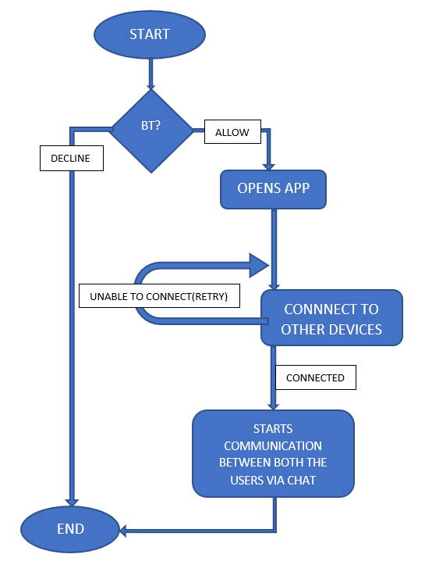

**CHAPTER 5 – System Implementations**

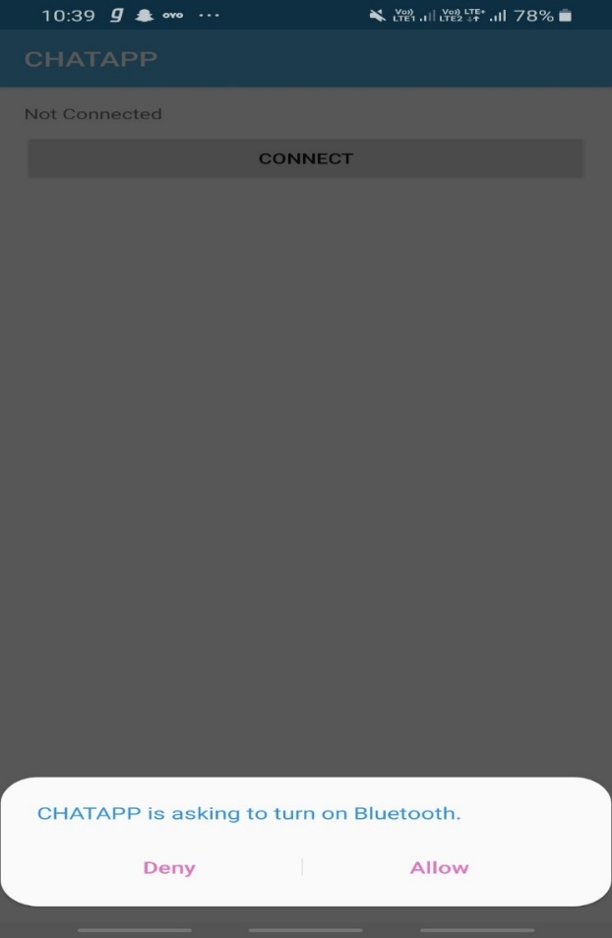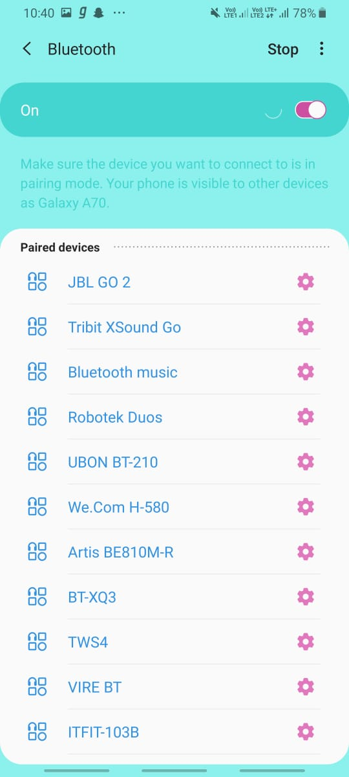

After getting the permission to turn on Bluetooth our app will start scanning near by Bluetooth devices

When we open our app and if we didn’t turn on Bluetooth they will ask to turn on Bluetooth

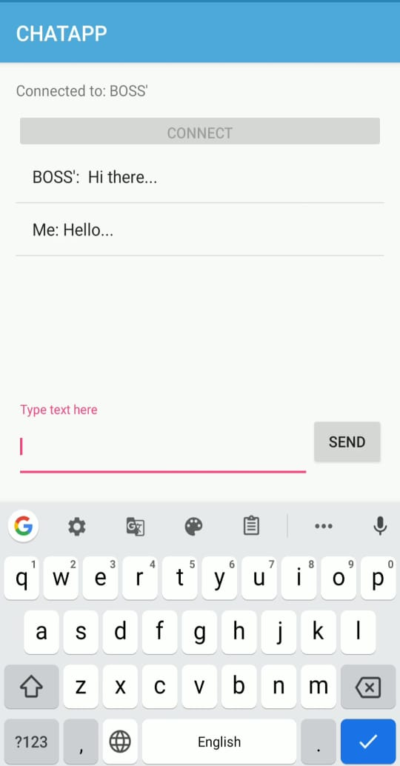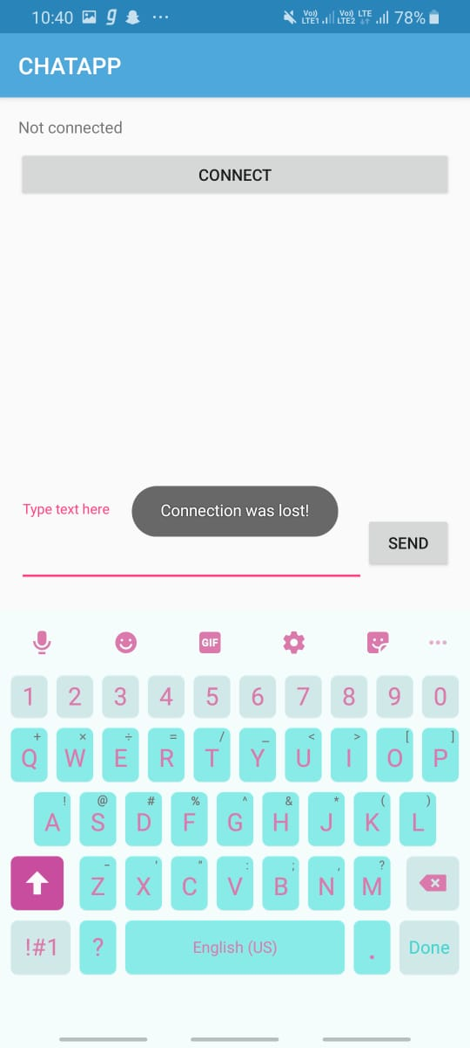

When connection is perfect we can chat with the connected device

When no Bluetooth device found it will display toast “connection lost”.

**CHAPTER 6 - Limitations**

* There are few limitations in this application :
* We can’t chat when we are at far distance.
* We can’t share files with this app.
* We can’t connect multiple devices

**CHAPTER 7 - Outcome**

Bluetooth chat application is developed in the ANDROID platform. CHATAPP establishes full-duplex communication between differing and same ANDROID OS. It supports half-duplex in terms of Bluetooth version incompatibility and requires version compatibility of Bluetooth to enable full-duplex communication. Here both the persons can send message to each other.

We can expect bluetooth chat communications with multiple devices in the future. However, as Bluetooth is less secure than Wi-Fi based communication, a secure mode of communication that encrypts and decrypts data using any one of the traditional encryption algorithm could be used for secure data communication.

**CHAPTER 8 – Future Enhancement**

* As we all know that the range of Bluetooth is short so we are trying to extend the range of Bluetooth.
* As Bluetooth devices can't connect to multiple once it is connected to one device. So we are trying to make a Multiuser Bluetooth chat app.
* In our Chat app we can’t send emoji's to the express our emotions so we are trying to solve this problem to in future.

**CHAPTER 9 - Bibliography**

**REFERENCES**

1. **Android Studio Tutorial :**

<https://www.tutorialspoint.com/android/android_studio.htm>

1. **Bluetooth Connectivity :**

<https://www.tutorialspoint.com/android/android_bluetooth.htm>

1. **Chatting :**

<https://www.applozic.com/blog/android-chat-app-tutorial-using-android-studio/>

1. **How Bluetooth Works (2000) :**

<https://electronics.howstuffworks.com/bluetooth.htm>